**Project Content of Digital Human**

In order to enhance user immersion and human-computer interaction, we also provide user-selectable voice cloning and embed a virtual human in the platform that can interact with the user.

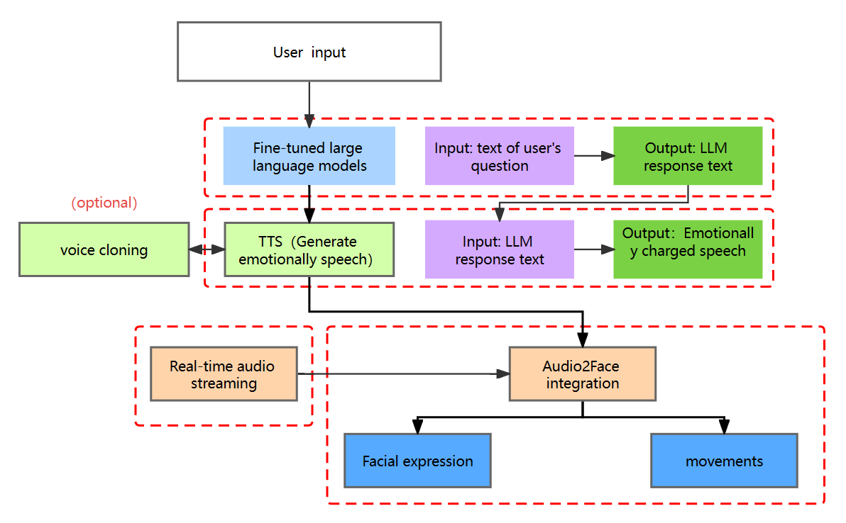

The construction of the Digital Man module is divided into the following sections.

（1）Semantic understanding using our own fine-tuned large language models: The specially fine-tuned large language model ensures deep semantic understanding and provides well-targeted solutions that allow the model to better understand and answer questions related to school life, such as campus facilities, admissions process, course information, etc.

（2）Generate emotionally charged speech through TTS services: The Text-to-Speech (TTS) service converts response text into emotionally charged speech files. This process takes into account natural emotion expression, speech synthesis quality, real-time performance and file stability. In addition, we will introduce optional voice cloning to meet the needs of users for voice customisation. 4.

（3）Real-time audio streaming via gRPC protocol: Communicate with Audio2Face streaming audio player via gRPC protocol to achieve real-time streaming voice output.

Setup, configure and transfer voice data for playback in real time. 5.

（4）Audio2Face integration for digital human interaction: Use Audio2Face technology to generate real-time animations for UE5's digital human facial expressions and movements, enhancing the immersive user experience with realistic and responsive interactions.